NOTICE OF ANNUAL PARISH MEETING
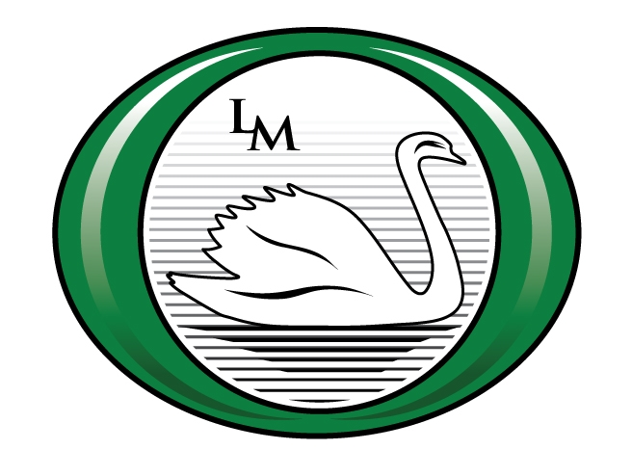
Little Marlow Parish
Notice is Hereby Given that Little Marlow Parish Council will be holding a

PARISH MEETING
At
Abbotsbrook Village Hall, Marlow Road, Well End
On
Friday 18th May from 8pm.

All electors of the Parish can attend and vote at the meeting, at which any Parish matters can be raised.

AGENDA

- Introduction by Chairman of Little Marlow Parish Council
- Apologies for Absence
- Geoffrey Moss Memorial Rose Bowl Presentation
- Minutes of previous meeting held on Friday 19th May 2017
- Chairman’s Annual Report
- Financial Report
- Planning Report
- Report from Rt Hon Dominic Grieve MP QC
- Report from Thames Valley Police
- Speaker – Athletics Track
- Other matters

After the business of the meeting has been completed there will be an opportunity to circulate with representatives of the Council and other organisations, as well as other members of the electorate.

Refreshments will be available.

Signed: Valerie Brownridge – Chairman of the Council
Date: 1st May 2018

